Practical No. 10
Aim : WAP in C for Parity Check Error Detection

Name : Danish Altaf Solkar | Class : CO - B
Enrolment no. : 24111590805 | Batch : 2

Code :-
#include <stdio.h>
#include <conio.h>
int main()
{
int data[20], received[20];
int n, i, count = 0, rcount = 0, parity;

clrscr();
// Sender side
printf("Enter number of data bits: ");
scanf("%d", &n);

printf("Enter data bits (0 or 1): ");
for(i = 0; i < n; i++)
{
scanf("%d", &data[i]);
if(data[i] == 1)
{
count++;
}
}

// Even parity generation
parity = (count % 2 == 0) ? 0 : 1;
printf("Generated parity bit: %d\n", parity);

// Receiver side
printf("\nEnter received bits including parity bit: ");
for(i = 0; i <= n; i++)
{
scanf("%d", &received[i]);
if(received[i] == 1)
{
rcount++;
}
}

// Error detection
if(rcount % 2 == 0)
{
printf("No error detected.\n");
}
else
{
printf("Error detected in received data.\n");
}
getch();
return 0;
}

OUTPUT :-

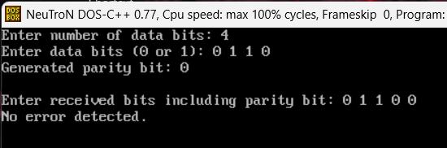

Process related  (15) | Product related  (10) | Total Marks  (25) | Signature

